3.3HW.R
garrett
2025-02-12
library(Lock5Data)
library(tidyverse)
## ── Attaching core tidyverse packages ──────────────────────── tidyverse 2.0.0 ──
## ✔ dplyr 1.1.4 ✔ readr 2.1.5
## ✔ forcats 1.0.0 ✔ stringr 1.5.1
## ✔ ggplot2 3.5.1 ✔ tibble 3.2.1
## ✔ lubridate 1.9.4 ✔ tidyr 1.3.1
## ✔ purrr 1.0.2
## ── Conflicts ────────────────────────────────────────── tidyverse_conflicts() ──
## ✖ dplyr::filter() masks stats::filter()
## ✖ dplyr::lag() masks stats::lag()
## ℹ Use the conflicted package (<http://conflicted.r-lib.org/>) to force all conflicts to become errors
CarDep <- data("CarDepreciation")
head(CarDepreciation)
## Car New Used Depreciation
## 1 Mazda3 17956 15326 2630
## 2 Buick Encore 23633 21498 2135
## 3 Toyota Corolla 16091 14761 1330
## 4 Chrevolet Tahoe 45489 43463 2026
## 5 Chrevolet Equinox 21596 19149 2447
## 6 Ford Fiesta 14246 12220 2026
# step 1 Find mean and SD
mean_depreciation <- mean(CarDepreciation$Depreciation)
sd_depreciation <- sd(CarDepreciation$Depreciation)
mean_depreciation
## [1] 2355.85
sd_depreciation
## [1] 857.9969
# Step 2 Create a bootstrap
# Load necessary library
library(boot)
boot_mean <- function(data, indices) {
return(mean(data[indices]))
}
set.seed(123)
bootstrap_results <- boot(CarDepreciation$Depreciation, boot_mean, R = 10000)
bootstrap_means <- bootstrap_results$t
hist(bootstrap_means, main="Bootstrap Distribution of Mean Depreciation",
xlab="Mean Depreciation", col="lightblue", breaks=30, border="black")
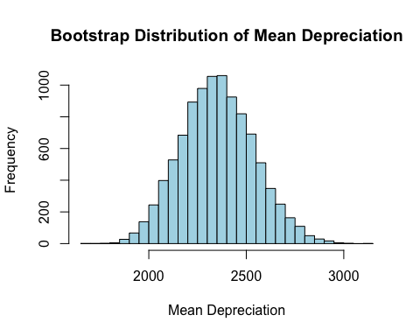
# Describe the Bootstrap Shape = Normal center, Center = Close to mean
se_bootstrap <- sd(bootstrap_means)
se_bootstrap
## [1] 187.3405
# Step 3 95% confidence interval
# Compute the standard error
se_bootstrap <- sd(bootstrap_means)
ci_lower <- quantile(bootstrap_means, 0.025)
ci_upper <- quantile(bootstrap_means, 0.975)
se_bootstrap
## [1] 187.3405
ci_lower
## 2.5%
## 2003.449
ci_upper
## 97.5%
## 2737.801

